# **Airplane Passenger Satisfaction Dashboard**

## **Introduction**

# **Power BI** offers insightful data on passenger satisfaction according to travel type and customer type. It also contains data on the proportion of returning passengers that are male and female, how flight distance affects passenger preferences, and the main elements that influence passenger happiness. This dashboard, which makes use of Microsoft Power Bi's capabilities, gives airlines a useful tool for comprehending and improving the entire traveler experience.

# Screenshot 2024-04-15 114343**Screenshot 2024-04-15 134954**

**Objective**

The aim of this project is to uncover the critical elements that impact passenger satisfaction levels by analyzing and visualizing the data linked to passenger satisfaction. Airlines will be able to improve their services and make well-informed judgments thanks to the insights gathered from this investigation.

**Data Collection**

The data-set was taken from Web as a CSV file and it contains Airline Satisfaction Scores for 129,880 passengers spread across 23 fields.

**Gender:**Gender of the passengers (Female, Male)

**Customer Type:** The customer type (Loyal customer, disloyal customer)

**Age:** The actual age of the passengers

**Type of Travel:**Purpose of the flight of the passengers (Personal Travel, Business Travel)

**Class:** Travel class in the plane of the passengers (Business, Eco, Eco Plus)

**Flight Distance:** The flight distance of this journey

**In-flight Wi-Fi Service:** Satisfaction level of the in-flight Wi-Fi service (0: Not Applicable; 1-5)

**Departure/Arrival Time Convenience:**Satisfaction level of Departure/Arrival time convenient

**Ease of Online Booking:** Satisfaction level of online booking

**Gate Location:**Satisfaction level of Gate location

**Food and Drink:** Satisfaction level of Food and drink

**Online Boarding:** Satisfaction level of online boarding

**Seat Comfort:** Satisfaction level of Seat comfort

**In-flight Entertainment:** Satisfaction level of in flight entertainment

**On-board Service:** Satisfaction level of On-board service

**Leg Room Service:**Satisfaction level of Leg room service

**Baggage Handling:** Satisfaction level of baggage handling

**Check-in Service:** Satisfaction level of Check-in service

**In-flight Service:** Satisfaction level of in flight service

**Cleanliness:**Satisfaction level of Cleanliness

**Departure Delay in Minutes:** Minutes delayed when departure

**Arrival Delay in Minutes:** Minutes delayed when Arrival

**Satisfaction:** Airline satisfaction level (Satisfaction, neutral, or dissatisfaction)

**Data Cleaning and Preparation**

Before analysis, the data was thoroughly cleaned and prepared. This included deleting duplicates, managing missing values, and assuring data consistency. Furthermore, data transformations and aggregations were used to generate relevant metrics and variables for study

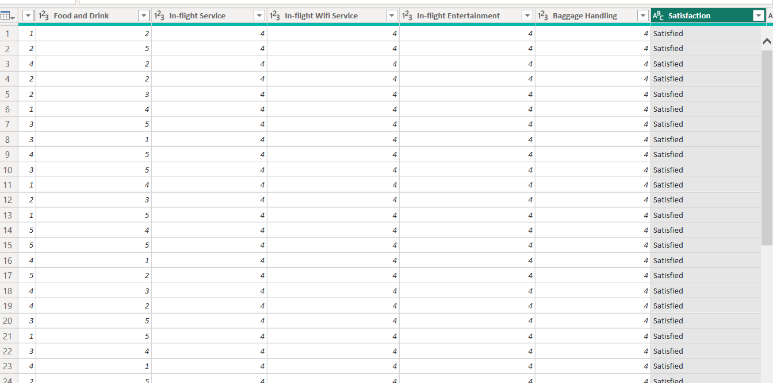

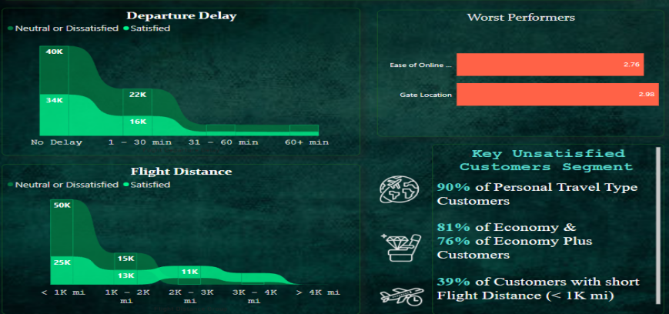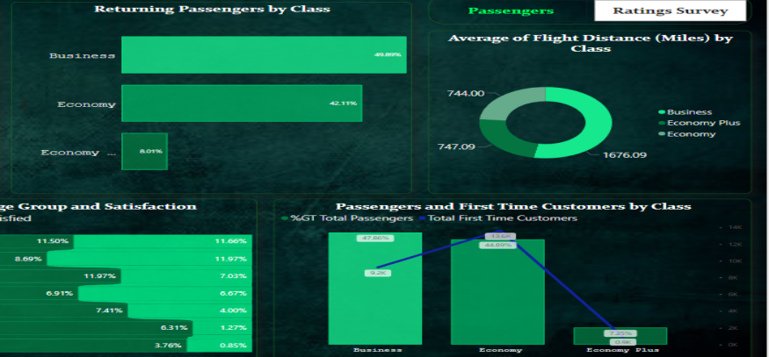

The data were examined and visualized using Microsoft Power BI in order to find significant trends and insights. To display the data in an understandable and visually appealing way, visualizations such interactive dashboards, bar charts, ribbon charts, and donut charts were developed. With the help of these visualizations, users can investigate passenger satisfaction according to many parameters, including customer type, kind of trip, and particular aspects that influence satisfaction.

**Key Performance Indicators (KPI’s)**

KPI’s are metrics that organizations use to monitor and assess their progress toward certain business goals. They are used to track performance over time and enable businesses to make data-driven decisions based on actual outcomes. KPI’s are qualitative or quantitative measures of an organization's or department's objectives. They are critical indicators that support organizations to determine areas for improvement, establishing targets for future accomplishments, and monitoring their success in achieving the goals they have established.

1. Passengers in Total: The total number of passengers that are present in the data-set.
2. Male Passenger Percentage: The proportion of male passengers in the data-set.
3. Female Passenger Percentage: The proportion of female passengers in the data-set.
4. The percentage Customers flying for the first time: The proportion of travelers using the airline for the first time.
5. Percentage of Repeat Customers: The proportion of travelers who have already taken a flight with the airline.
6. The percentage initial Male Customers: The proportion of men traveling for the first time on flights operated by the airline.
7. The percentage initial Female Customers: The proportion of female travelers who are on their first flight with the airline.
8. The percentage of male passengers who have returned to the airline after a previous flight.
9. The percentage of female passengers who have previously flown with the airline and are returning customers.
10. Average Arrival Delay: The mean number of minutes that flights take longer than expected to arrive.
11. Average Departure Delay: The mean number of minutes that flights typically experience a delay before taking off.
12. The average flight distance, measured in miles, is the distance that aircraft typically travel.
13. Total Customers for Business Travel: The total number of travelers using a vehicle for business.
14. overall Customers on Personal Travel: The overall number of travelers on personal travel.
15. overall Customers Satisfied: The overall number of travelers who expressed contentment with their flight experience.
16. Total Unsatisfied Passengers: The total number of travelers that expressed ambivalence or discontentment over their flight experience.
17. Satisfaction Rate: The proportion of passengers who expressed satisfaction with their flight experience, determined by dividing the total number of passengers by the total number of pleased customers.
18. Dissatisfaction Rate: The ratio of Total Dissatisfied Customers to Total Passengers indicates the proportion of passengers who expressed indifferent or dissatisfaction with their flying experience.

## **Insights and Recommendation**

* With an average rating of 2.76, **Ease of Online booking** service is the factor with the lowest rating. To meet quality standards, adjustments and inspections must be made. Additionally, give users clear access instructions and boost the service's performance and dependability.
* Enhancing UI/UX and investigating website analytic are two ways to optimize online booking. To make the booking process more convenient and customized for each consumer, provide personalized alternatives and recommendations.
* A good and easily accessible gate location facilitates efficient boarding. Enhance communication further by giving prompt and accurate gate information. You may also streamline the boarding process by utilizing technology like digital displays and smart-phone apps.
* Increasing the frequency of cleaning will help to guarantee that aircraft are properly cleaned in between flights, improving flight cleanliness. To increase overall customer satisfaction, teach cleaning personnel best practices, safety procedures, and how to use cleaning products correctly.
* 90% of personal travel clients are dissatisfied, and the airline should work to improve the in-flight experience. More entertainment options, comfortable seating, and healthier food selections can boost customer satisfaction. Furthermore, providing flexible booking choices, such as free cancellations or adjustments, can reduce the burden of travel planning and make the overall experience more enjoyable.
* 81% of the economy and 76% of the economy plus customers are unsatisfied, thus the airline should prioritize enhancing the in-flight experience for these passengers. More legroom, higher-quality seats, and complimentary snacks and beverages can boost consumer satisfaction. Airlines may also consider charging an additional price for premium facilities like priority boarding or in-flight Wi-Fi to consumers who are prepared to pay for a better experience.
* 76% of first-time customers are dissatisfied; airlines should prioritize providing a great first-time experience to secure customer retention. Furthermore, offering clients with individualized recommendations based on their travel preferences might assist to increase customer loyalty.
* Customers aged 18 to 25 and 25 to 35 are severely unsatisfied. The airline should perform market research to better understand the wants and tastes of younger clients, and then modify its offerings to suit those expectations. This might include giving lower tickets, adding more entertainment options on board, and improving the entire consumer experience.
* 82% of senior individuals are unsatisfied, thus the airline should consider offering more support to older travelers. Airlines can also consider offering discounted rates to senior adults to demonstrate their respect for this important client demographic.
* 39% of consumers on short-distance flights (<1K km) are unsatisfied, highlighting the need for airlines to improve the in-flight experience. Providing comfortable seating and entertainment alternatives can enhance the flight experience. In addition, airlines should consider offering flexible ticketing options for short-haul flights to make it easier for passengers to book and change their travel arrangements.

**Conclusion**

In conclusion, based on an examination of airline passenger satisfaction data, it is obvious that certain critical areas must be addressed in order to raise overall satisfaction. These areas include improving cleanliness, reducing departure and arrival delays, providing more personalized service, increasing comfort, and focusing on the needs of key dissatisfied customer segments such as personal travelers, economy class passengers, first-time customers, senior citizens, and customers flying short distances. By applying the proposed data-driven methods, the airline can increase client fulfillment and enhance the entire customer experience. The Power BI dashboard report provides a thorough overview of the key performance indicators and insights obtained from the analysis, allowing the airline leadership team to make educated decisions.

**Report By** : Kunal Udapure